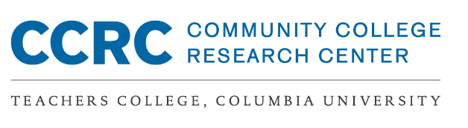

Activity A: Mapping the Current Program Onboarding Experience at Your College
Complete a first draft of this activity with your team prior to meeting with your coach in advance of the virtual institute.
What is the current program onboarding experience for the majority of students at your college under each of the design principles in the Ask–Connect–Inspire–Plan framework?
Refer to the CCRC brief, Research Evidence on Community College Ask-Connect-Inspire-Plan Onboarding Practices, for more information about the ACIP framework.
 | Ask every student about their interests, strengths, life circumstances, and aspirations | Connect students with faculty, students, alumni, and others with similar interests | Inspire learning in term 1 through “light-the-fire” college-level courses on issues of interest | Help every student develop an individualized educational plan aligned to jobs/ transfer in their field of interest by the end of term 1
What do most students experience during onboarding? | Current experience:  - Where:  - When:  - With whom:  - How consistently: | Current experience:  - Where:  - When:  - With whom:  - How consistently: | Current experience:  - Where:  - When:  - With whom:  - How consistently: | Current experience:  - Where:  - When:  - With whom:  - How consistently:

Activity B: Revisiting Your Program Enrollment Data
As a team, review the Program Enrollment Tables and the Power Point slides provided by CCRC at Institute 2 in October. Complete the following prior to your coach meeting in advance of the virtual institute.

Identify 3-5 data points that are promising about your program enrollment based on the data tables and feedback from CCRC.

1,
2,
3,
4,
5,

Identify 3-5 data points that are concerning about your program enrollment based on the data tables and feedback from CCRC.

1,
2,
3,
4,
5,

