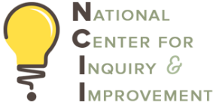
NCII Rural Pathways Project
Institute 3: Advancing DEEP K12 Pathways
Team Session #2 – March 12, 2026

Introduction
Use this team time to begin working on this activity at the institute; after the institute, engage campus and K12 stakeholders to further discuss and fully complete the prompts. Submit all completed team time documents to Sarah Cale at sarah@ncii-improve.com by April 24th.

Instructions
Take five minutes to have each team member review the National Alliance of Concurrent Enrollment Partnerships (NACEP) Simplified Program Practice Checklist. As a group, using the prompts as a guide, discuss the current state of your K12/community college dual enrollment partnership(s). Identify 2-3 opportunities for growth in each section.

Section 1- Partnerships

Section 2 - Instructor Qualifications, Orientation & Support

Section 3 - Curriculum and Instructional Alignment

Section 4 - Student Support & Processes

Section 5 - Assessment & Evaluation

